Circulating Cinema. Moving Image Research and the Transnational Archive

International postgraduate workshop
King’s College London, British Film Institute

28 October– 30 October 2019

Sponsored by German Academic Exchange Service (DAAD)
In association with the German Screen Studies Network

Monday 28 October
Room: Bush House (SE) 2.01

9.30 Coffee and registration

10.00 – 11.30 Introduction
Erica Carter (King’s College London) and Elizabeth Ward (University of Hull)

KEYNOTE LECTURE
Circulating Audiovisual Memories: Archival Strategies of Curation
Dagmar Brunow, Linnaeus University, Växjö, Sweden

11.30 Coffee

11.45 – 13.00 Introduction to the Circulating Cinema Project
Erica Carter (King’s College London)

Focus on Distribution: Stanley Forman and ETV
Martin Brady and Franziska Nössig (King’s College London)

13.00 Lunch

14.00 Student presentations of own research and comments on reading

16.00 – 17.30 BFI Reuben Library Visit
Sarah Currant, Senior Librarian for Reader and Mediatheque Services, BFI
Reuben Library

18.30 Film Screening (King’s Building K6.63)
Indian Life (John Jewell, 1940) (18 minutes); Around India with a Movie
Camera (Sandhya Suri, 2018) (72 minutes)

20.00 Dinner
Tuesday 29 October
Room: Bush House (SE) 2.05

10.30 Whose Film Heritage? Mining Britain’s Colonial Film Archive
Grazia Ingravalle, Brunel University London

12.30 Lunch

13.30 Exile Film history: film culture networks and the print archive
Julia Eisner (King’s College London and Tashi Petter (Queen Mary University
of London)

15.00 Group Research at BFI Library

18.00 Film Screening (Nash Lecture Theatre, King’s Building K2.31)
Fair Rent (cinemat. Wolf Suschitsky, dir. Mary Beales, 1947) (11 minutes); The
Small World of Sammy Lee (cinemat. Wolf Suschitsky, dir. Ken Hughes, 1963)
(107’ minutes)

Wednesday 30 October
Room: Bush House (SE) 1.06

10.00 – 12.00 BFI, 21 Stephen St, London W1T 1LN
Whose film heritage II?
Tour and talk by Patrick Russell, Head of Non-Fiction, BFI National Archive

12.30 Lunch (King’s College London)

13.30 – 15.00 Plenary and Future Networking

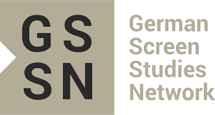
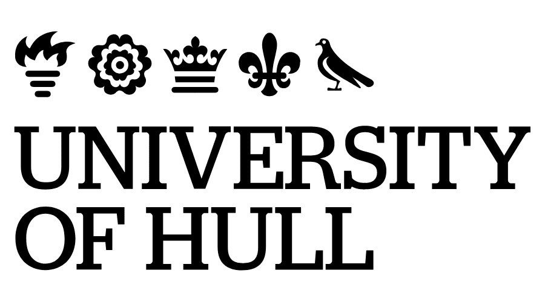
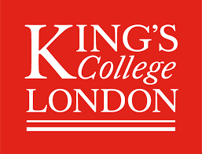
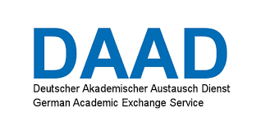
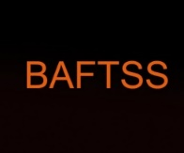

Participants and Speakers

Lawrence Alexander (University of Cambridge)
Martin Brady (King’s College London)
Dagmar Brunow (Linnaeus University)
Erica Carter (King’s College London)
Victor Manuel Chavez (Philipps-Universität Marburg)
Sarah Currant (British Film Institute)
Hanja Daemon (King’s College London)
Julia Eisner (King’s College London)
Brittany Eldridge (University College London)
Amy Fligelstone (Lancaster University)
Andrea Gelardi (University of St Andrews)
Eleanor Halsall (King’s College London)
Grazia Ingravalle (Brunel University London)
Himadri Ketu (Albert-Ludwigs-Universität Freiburg)
Patricia Lehner (University College London)
Leila Mukhida (University of Cambridge)
Franziska Nössig (King’s College London)
Joseph Prestwich (King’s College London)
Tashi Petter (Queen Mary University of London)
Anushrut Ramakrishnan Agrwaal (University of St Andrews)
Anja Rekeszus (King’s College London)
Christian Rüdiger (Freie Universität Berlin)
Patrick Russell (British Film Institute)
Elizabeth Ward (University of Hull)
Fabienne Wolf (Goethe-Universität, Frankfurt)

